**DAILY ONLINE ACTIVITIES SUMMARY**

|  |  |  |  |  |  |  |  |
| --- | --- | --- | --- | --- | --- | --- | --- |
| **Date:** | 21-06-2020 | | | | **Name:** | Gudugunti Anirudh | |
| **Sem & Sec** | IV - A | | | | **USN:** | 4AL18CS023 | |
| **Online Test Summary** | | | | | | | |
| **Subject** | | Not conducted | | | | | |
| **Max. Marks** | | ---- | | **Score** | | ---- | |
| **Certification Course Summary** | | | | | | | |
| **Course** | C tutorials | | | | | | |
| **Certificate Provider** | | | Solo learning.com | **Duration** | | | **5modules** |
| **Coding Challenges** | | | | | | | |
| **Problem Statement:** 1: Program that compares counting words in files using an ArrayList and a Map. | | | | | | | |
| **Status:** Completed | | | | | | | |
| **Uploaded the report in Github** | | | | yes | | | |
| **If yes Repository name** | | | | https://github.com/alvas-education-foundation/anirudh_gudugunti/tree/master/daily_progress | | | |
| **Uploaded the report in slack** | | | | yes | | | |

**Online Test Details: Not conducted**

Snapshot of certification course:

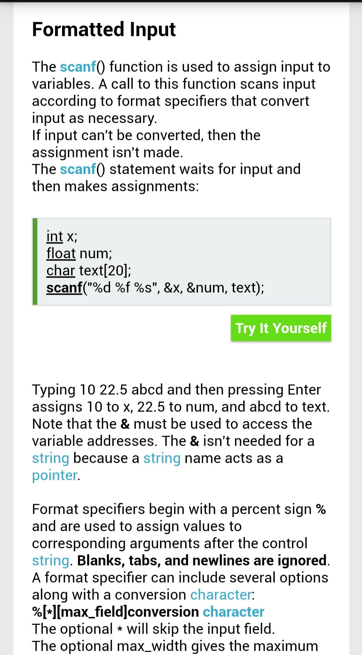

**1.** Formatted input/output statements.

2. Importance of using scanf and printf statements.

3. How and where to use format specifiers.

**Online coding:**

Problem 1: (using JAVA) Program that compares counting words in files using an ArrayList and a Map.

